

# SE Project Proposal

**Course:**

CMPE-311L (Software Engineering)

**Session:**

CE-20 (Fall 2022)

# Project Title:

Smart Health-Care System

**Group Members:**

Iqra Muzaffar (2020-CE-45)

Hooria Azeem(2020-CE-46)

Palwasha Zulfiqar (2020-CE-48)

**Submitted To:**

Sir Asim Rehmat

Miss Sana Tasleem

**Date: September 28, 2022**

**Problem Statement**

Our aim for the project is to automate “a hospital system”. In hospitals, a patient has to wait in queues for his appointment which may get cancelled as-well .Hospital environment is not so friendly for a patient as other effected patients may cause adverse effect on patient’s Health.

**Abstract:**

The purpose of the Smart health care system is to automate an existing manual system by the help of a software where the data can be stored for longer periods with easy access and manipulation for free, secure and efficient management system. The system manages doctors, appointments, patient , booking, doctors schedule, patent records. System allows both (video consultation and live appointment booking) as per the patient’s satisfaction.

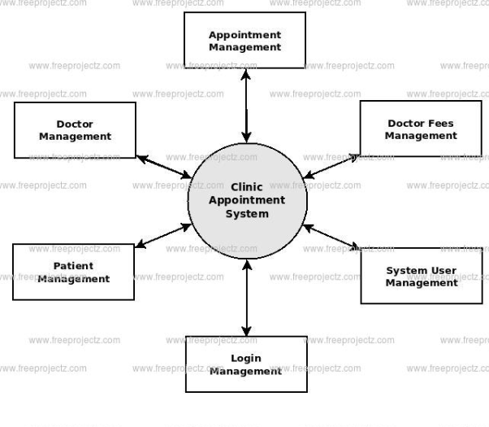

# Functionalities:

# Provides searching facilities based on various factors such as doctor, patient ,doctor schedule

# Manages doctor’s fee details online

# Tracks all information of appointment, doctor fees, doctor schedule , patient records (add, update ,delete ,show)

# Allows Video consultation and live appointment for patient

# Reschedules an appointment after the prescribed time and notifies patient for an upcoming appointment.

# Provides a prescription/report and recommended medical store by the doctor for easy availability of medicines.

# Prescribed Tests By doctor and relevant laboratory details.

# Prioritises “Emergency-Patient” for appointment booking.

# 

**Implementation (key points, tentative, technologies):**

* A web application for Health system
  + Front end using HTML, CSS, REACT, JQUERY
  + MySQL for database
  + Backend frame works()
* Advanced features
* Video consultation
* Appointment Reschedule
* Online Payment
* User Recommended Search
* Prioritising “Emergency Patient”

**Future Work:**

* Android App
* Deploy on cloud

**References**:

<https://www.practo.com/order?utm_source=practonavbar&utm_medium=referral&utm_campaign=practonavbarredirect>

<https://www.freeprojectz.com/dfd/clinic-appointment-system-dataflow-diagram>

**Comments:**

**______________**

**Signature**